# **Operating System Lab Assignment II**

### **4ITRC2**

*Purvanshi Patidar*

*BE II Year*

*Information Technology - ‘A’*

# Aim

To study and understand Ubuntu Commands

# To perform

Execute different Commands

# To Submit

### **Part1** Outputs of the following commands

1. pwd



Prints the current working directory

1. cd



Changes the directory

1. ls

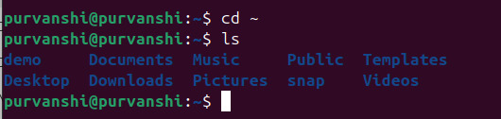

Lists files and directories

1. mkdir



Creates a new directory

1. rm



Removes files or directories

1. touch



Creates an empty file

1. hostname



Displays the system’s hostname

1. cat



Displays file contents

1. chmod



Changes file permissions

1. echo



Prints text to the terminal

1. grep



Searches for patterns in files

1. fgrep



Searches for fixed strings in files

1. mv



Moves or renames files

1. cp



Copies files and directories

1. more

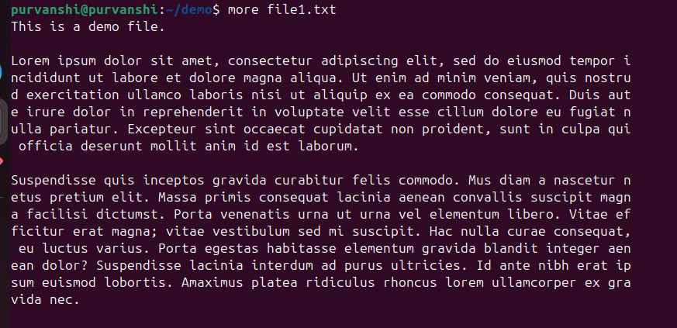

Views file content page by page

1. less

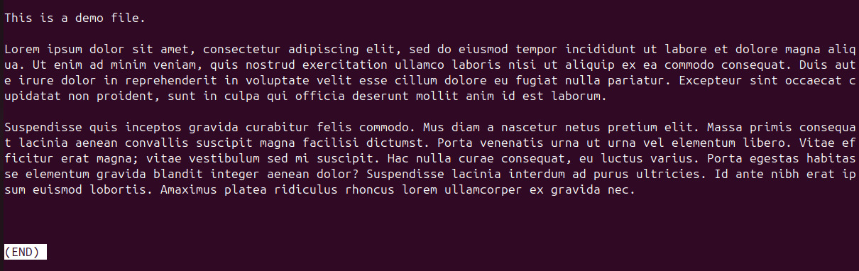Similar to more, but allows backward navigation

1. wc



Counts lines, words, and characters in a file

1. awk

Text processing and pattern scanning

1. sed

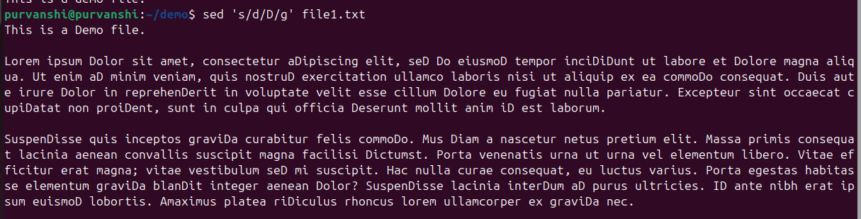

Stream editor for text manipulation

1. tail

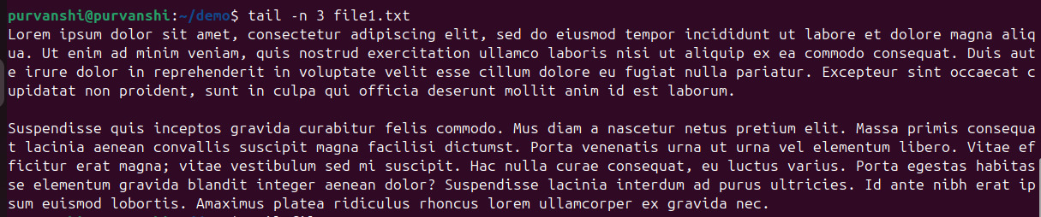

Displays the last lines of a file

### **Part 2** Answers to the following Questions: (you need to supply commands)

1. **How to navigate to a Specific Directory?**

To navigate to a specific directory, use the cd command:

**cd /path/to/directory**

Change to home directory:

**cd ~ or just cd**

Go up one level:

**cd ..**

1. How to see detailed information about files and directories using ls?

For detailed information about files and directories, use ls with the -l flag:

**ls -l**

This will list the file permissions, number of links, owner, group, size, date/time, and name.

If you wish to see hidden files too:

**ls -la**

1. How to create multiple directories in Linux using `mkdir` command?

We can create multiple directories with a single command by listing all directory names:

**mkdir dir1 dir2 dir3.**

1. How to remove multiple files at once with rm?

**rm file1.txt file2.txt file3.txt…**

If you want a prompt before removal:

**rm -i file1.txt file2.txt…**

If you want to force remove without prompting:

**rm -f file1.txt file2.txt…**

1. Can rm be used to delete directories?

Yes, but you need to use the -r along with rm:

**rm -r directoryname**

For empty directories, you can also use rmdir:

**rmdir directoryname**

1. How Do You Copy Files and Directories in Linux?

To copy files:

**cp sourcefile.txt destination path**

To copy directories (with all contents), use the -r flag:

**cp -r sourcedir destinationdir**

1. How to Rename a file in Linux Using mv Command

**mv oldname.txt newname.txt**

1. How to Move Multiple files in Linux Using mv Command

To move multiple files, list all the files you want to move with the destination directory at the end:

**mv file1.txt file2.txt file3.txt… destinationdir/**

1. How to Create Multiple Empty Files by Using Touch Command in Linux

This command creates multiple empty files or updates the timestamp if the files already exist.

**touch file1.txt file2.txt file3.txt…**

1. How to View the Content of Multiple Files in Linux

Using cat for multiple files:

**cat file1.txt file2.txt file3.txt**

1. How to Create a file and add content in Linux Using `cat` Command

**cat > filename.txt**

**…File Content…**

Press Ctrl+D when done.

1. How to Append the Contents of One File to the End of Another File using cat Command

**cat sourcefile.txt >> destinationfile.txt**

1. How to use cat command if the file has a lot of content and can’t fit in the terminal.

Use less instead of cat if the file has a lot of content and can’t fit in the terminal:

**less filename.txt**

1. How to Merge Contents of Multiple Files Using `cat` Command

**cat file1.txt file2.txt file3.txt… > mergedfile.txt**

1. How to use cat Command to Append to an Existing File

**cat >> filename.txt**

**…Type content here…**

Press Ctrl+D when finished.

1. What is “chmod 777 “, “chmod 755” and “chmod +x “or “chmod a+x”?

Each digit represents permissions for the user, group, and others, respectively. And each digit is a sum of the following values:

4: Read (r)

2: Write (w)

1: Execute (x)

So,

chmod 777: Gives read, write, and execute permissions to owner(4+2+1), group(4+2+1), and others (4+2+1)

chmod 755: Gives read, write, execute to owner(4+2+1); read and execute to group(4+1) and others(4+1)

chmod +x: Adds execute permission for the current permission set

chmod a+x: Adds execute permission for all (owner, group, others)

1. How to find the number of lines that matches the given string/pattern

**grep -c "pattern" filename.txt**

1. How to display the files that contains the given string/pattern.

**grep -l "pattern" file1.txt file2.txt file3.txt…**

Or for all files in a directory:

**grep -l "pattern" \***

1. How to show the line number of file with the line matched.

**grep -n "pattern" filename.txt**

1. How to match the lines that start with a string using grep

**grep "^string" filename.txt**

1. Can the ‘sort’ command be used to sort files in descending order by default?

**sort -r filename.txt**

1. How can I sort a file based on a specific column using the ‘sort’ command?

**sort -k column_number filename.txt**